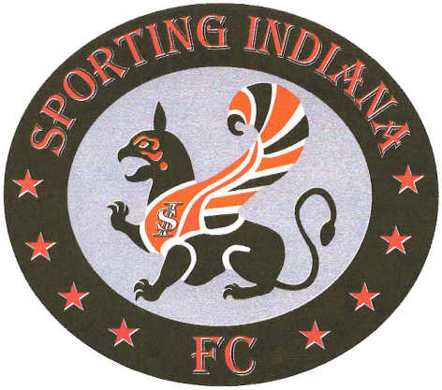
Technical Training Schedule
Sporting Indiana U8-U14

April 18th  Focus: Individual Dribbling  - Dribbling moves and technique  - Attacking defenders off the dribble  - Attacking space with the dribble | May 16th  Focus: First Touch/leading touch  - Directing the ball  - Decision to move  - Body parts for different play
April 25th  Focus: Passing  - Passing technique  - Passing to players  - Passing to space | May 23rd  Focus: Pressure, Cover, balance  - Playing group defense  - Pressuring ball  - Sitting in passing lanes
May 2nd  Focus: Combination Play  - Playing in tandem and trio  - Wall Passes and overlaps  - Attacking space w/o ball  - Running routes | May 30th  Focus: Finishing  - Striking the ball to finish  - Parts of the foot  - Head
May 9th
Focus: Individual Defense
- The four S’s
- The Block Tackle
- Containment vs tackle

