SPORTING INDIANA FC 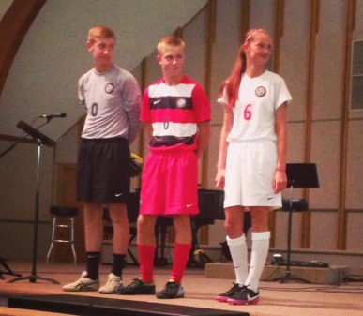
Dear SIFC families,
I know that you have all been anxiously awaiting the go ahead and instructions to order uniforms for your player(s) and SIFC would like to thank you for your patience as we transition to a new supplier. It’s finally that time! SIFC has contracted with Soccer Village to be the supplier of our new Nike uniforms.
PLEASE READ ALL OF THE ** NOTES THAT FOLLOW…
Returning players will automatically be given their same number.
** Ordering is OPEN, but Soccer Village will NOT process your order if I have not provided them with your team roster, along with each player’s number. There is not an option for you to enter that while placing your order. If you are a new player to SIFC, you should have heard from your coach or team manager by now about this. If you have not, contact your coach immediately!
UNIFORM TRY-ON
Soccer Village 2271 Pointe Parkway, Carmel, IN 46032. (317) 571-0105
Hours: Monday-Friday 10am-8pm, Saturday 10am-6pm, Sunday 12-5pm
Starting on Tuesday, October 7^{th – No appointment necessary!}
** Time is of the essence, so please get your kids over there asap so that you can move ahead with placing your order(s).

** REQUIRED UNIFORM PIECES – (Home kit) Nike Park Derby Jersey – White/White, Nike Classic Woven Short – White, and Nike Classic Sock – White AND (Away kit) Nike Squad 14 Pre-Match Top – Red/White/Black, Nike Classic Woven Short – Red, and Nike Classic Sock – Red.
** UNIFORM SIZES AND STYLES – Both the HOME and AWAY kits are available in BOYS (aka Youth), WOMENS & MENS. We are all familiar with the cuts for the youth and men’s sizes, the women’s sizes are a new option for us and they are less boxy in the shirt and a little shorter in the sleeve and length of the shorts. There is also an option for Girls length for the shorts. The girl in the photo above is 5’7” and she is wearing the Home kit in a WOMENS’s size M. The boy in the Away kit is wearing a MEN’s size M.
**FULL TIME GK’s - It is your choice to order one Green and one Silver Nike GK jerseys (short or long sleeve) that are offered on the site, Nike Classic Woven Short – Black & Nike Classic Sock – Black.
** PART TIME GK’s – You must order the Home kit, Away kit, and if you wish, any of the GK pieces. If you are unsure of your status, contact your coach ASAP.
** PRACTICE GEAR – SIFC players are issued 2 red cotton tees, at no extra cost, to wear for practices. Players must provide their own black shorts and socks. These can also be purchased on our Soccer Village ordering site. SIFC has also provided an option for players to purchase a red dri-fit tee, for those who do not like the cotton tee.
** ADDITIONAL CLOTHING & BACKPACK – These items are optional and are shown in our Soccer Village ordering site.
** SPIRIT WEAR – SIFC will notify you once these items come on-line and are available to order.
HOW TO PLACE YOUR SPORTING INDIANA FC UNIFORM ORDER:
- Go to www.soccervillage.com
- If you have never ordered from SV before, click on the SET UP NEW ACCOUNT in the upper right corner and follow the instructions.
- If you already have a SV account, click on WELCOME SOCCER VILLAGE CLUBS and scroll down until you see the Sporting Indiana FC logo and click on it. A screen will pop up asking you to sign-in.
- Then a screen will pop up asking you to enter our GROUP CODE. It is SIFC14.
- Scroll down to begin placing your order. Select the correct size and quantity for all items you want to purchase. Leave the items not needed as quantity zero.
- Select continue to view the items in your cart.
- Once confirmed, the final page will allow you to enter the player’s information and team. You will need to fill out the billing address and enter your credit card information. Visa, MasterCard and Discover are accepted.
- Shipping options: FREE – your order will be shipped to the SIFC Uniform Coordinator who will distribute it to you or your coach / team mgr at practice. UPS – your order will be shipped to your home and you will pay the cost of that service.

Thank you for being a part of Gryphon pride at Sporting Indiana FC!
Sincerely, Victoria Talbot
SIFC Uniform Coordinator
victoriatalbot@sportingindianafc.com

